Лабораторная работа №7
Тема: Создание операционного меню.
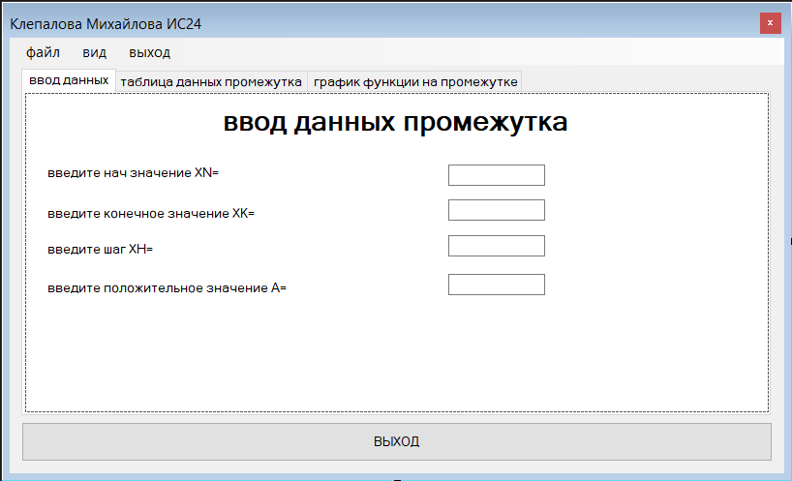
По дисциплине: Разработка программных модулей
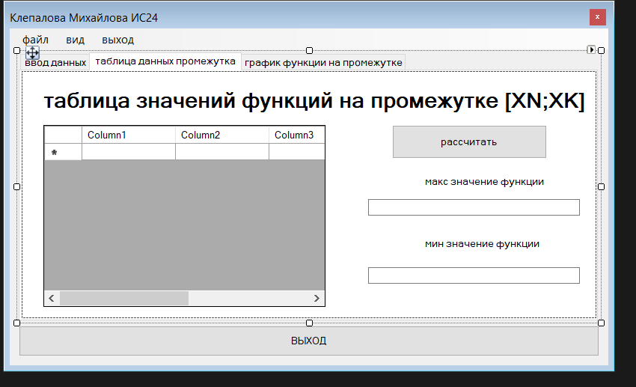
Рис1.Форма 1
Рис2.Форма 1
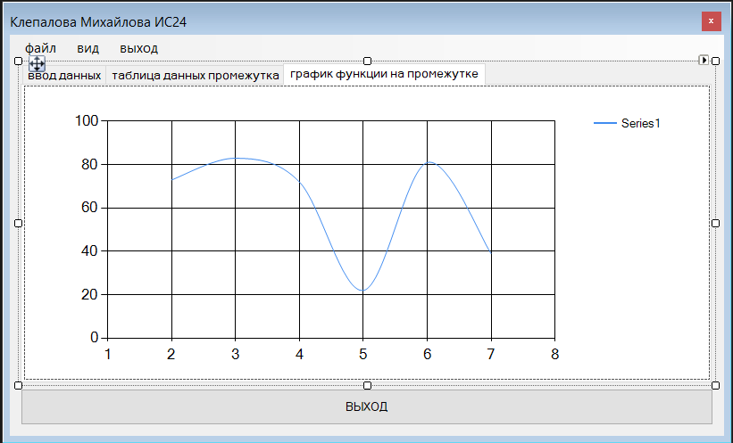
Рис3.Форма1
namespace СашаКрисЛАБА8
{
public partial class Form1 : Form
{
public static double xn, xk, xh, x, y, a, ymax, ymin, yt;

private void textBox1_KeyPress(object sender, KeyPressEventArgs e)
{
System.Windows.Forms.TextBox tb = sender as System.Windows.Forms.TextBox;
char number = e.KeyChar;
string sep = System.Globalization.CultureInfo.CurrentCulture.NumberFormat.NumberDecimalSeparator;

if (char.IsDigit(number) || char.IsControl(number)) return;

if (number == '-' && tb.SelectionStart == 0 && !tb.Text.Contains("-")) return;

if (number.ToString() == sep && tb.Text.Length > 0 && !tb.Text.Contains(sep)) return;

e.Handled = true;
}

private void textBox2_KeyPress(object sender, KeyPressEventArgs e)
{
System.Windows.Forms.TextBox tb = sender as System.Windows.Forms.TextBox;
char number = e.KeyChar;
string sep = System.Globalization.CultureInfo.CurrentCulture.NumberFormat.NumberDecimalSeparator;

if (char.IsDigit(number) || char.IsControl(number)) return;

if (number == '-' && tb.SelectionStart == 0 && !tb.Text.Contains("-")) return;

if (number.ToString() == sep && tb.Text.Length > 0 && !tb.Text.Contains(sep)) return;

e.Handled = true;
}

private void textBox3_KeyPress(object sender, KeyPressEventArgs e)
{
System.Windows.Forms.TextBox tb = sender as System.Windows.Forms.TextBox;
char number = e.KeyChar;
string sep = System.Globalization.CultureInfo.CurrentCulture.NumberFormat.NumberDecimalSeparator;

if (char.IsDigit(number) || char.IsControl(number)) return;
if (number == '-' && tb.SelectionStart == 0 && !tb.Text.Contains("-")) return;
if (number.ToString() == sep && tb.Text.Length > 0 && !tb.Text.Contains(sep)) return;

e.Handled = true;
}

private void textBox4_KeyPress(object sender, KeyPressEventArgs e)
{
System.Windows.Forms.TextBox tb = sender as System.Windows.Forms.TextBox;
char number = e.KeyChar;
string sep = System.Globalization.CultureInfo.CurrentCulture.NumberFormat.NumberDecimalSeparator;

if (char.IsDigit(number) || char.IsControl(number)) return;

if (number == '-' && tb.SelectionStart == 0 && !tb.Text.Contains("-")) return;

if (number.ToString() == sep && tb.Text.Length > 0 && !tb.Text.Contains(sep)) return;

e.Handled = true;
}

private void button2_Click(object sender, EventArgs e)
{
try
{

double xn = Convert.ToDouble(textBox1.Text);
double xk = Convert.ToDouble(textBox2.Text);
double h = Convert.ToDouble(textBox3.Text);
dataGridView1.Rows.Clear();
dataGridView1.Rows.Clear();
chart1.Series[0].Points.Clear();
chart1.Titles.Clear();
chart1.Titles.Add("График функции Вариант 9");

double maxVal = double.MinValue;
double minVal = double.MaxValue;

for (double x = xn; x <= xk + h / 2; x += h)
{

double y = Math.Pow(x, 5) + Math.Pow(x + 10, 1.0 / 3.0);

if (!double.IsNaN(y) && !double.IsInfinity(y))
{
dataGridView1.Rows.Add(Math.Round(x, 2), Math.Round(y, 3));
chart1.Series[0].Points.AddXY(Math.Round(x, 2), y);
if (y > maxVal) maxVal = y;
if (y < minVal) minVal = y;
}
}

textBox5.Text = Math.Round(maxVal, 3).ToString();
textBox6.Text = Math.Round(minVal, 3).ToString();

}
catch (Exception ex)
{
MessageBox.Show("Ошибка! Проверьте, что в полях ввода указаны числа. " + ex.Message);
}
}

private void высотаСтрокToolStripMenuItem_Click(object sender, EventArgs e)
{
Form2 f2 = new Form2();
if (f2.ShowDialog() == DialogResult.OK)
{
int newHeight = f2.InputValue;

dataGridView1.RowTemplate.Height = newHeight;

foreach (DataGridViewRow row in dataGridView1.Rows)
{
row.Height = newHeight;
}
}
}

private void ширинаСтолбцовToolStripMenuItem_Click(object sender, EventArgs e)
{
Form2 f2 = new Form2();
if (f2.ShowDialog() == DialogResult.OK)
{
int newWidth = f2.InputValue;

foreach (DataGridViewColumn col in dataGridView1.Columns)
{
col.Width = newWidth;
}
}
}

private void сохранитьДанныеТаблицыВФайлToolStripMenuItem_Click(object sender, EventArgs e)
{
SaveFileDialog sfd = new SaveFileDialog();
sfd.Filter = "Text files (*.txt)|*.txt|All files (*.*)|*.*";
if (sfd.ShowDialog() == DialogResult.OK)
{
StreamWriter sw = new StreamWriter(sfd.FileName);
sw.WriteLine("Результаты расчетов:");
sw.Close();
MessageBox.Show("Файл успешно сохранен");
}
}

private void цветТекстаToolStripMenuItem_Click(object sender, EventArgs e)
{
ColorDialog cd = new ColorDialog();
if (cd.ShowDialog() == DialogResult.OK)
{
dataGridView1.DefaultCellStyle.ForeColor = cd.Color;
}
}

private void tabControl1_SelectedIndexChanged(object sender, EventArgs e)
{
try
{

xn = double.Parse(textBox1.Text);
xk = double.Parse(textBox2.Text);
xh = double.Parse(textBox3.Text);
a = double.Parse(textBox4.Text);

if (tabControl1.SelectedIndex == 1)
{

}
else if (tabControl1.SelectedIndex == 2)
{

}
}
catch
{
MessageBox.Show("Введите корректные числовые данные!", "Ошибка");
tabControl1.SelectedIndex = 0;
}
}

private void button1_Click(object sender, EventArgs e)
{
Application.Exit();
}

private void выхоToolStripMenuItem_Click(object sender, EventArgs e)
{
Application.Exit();
}

private void выходToolStripMenuItem_Click(object sender, EventArgs e)
{
Application.Exit();
}

public static int i, k, j, h, m;
public Form1()
{
InitializeComponent();
}
}
}
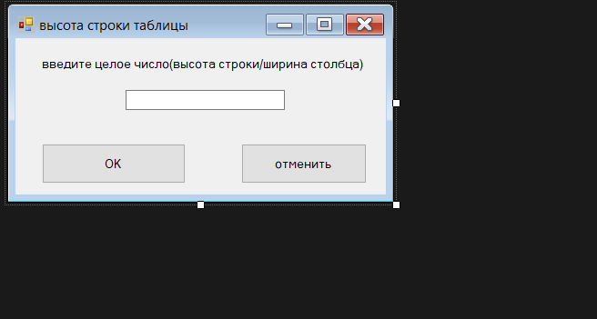
Рис4.Форма2
namespace СашаКрисЛАБА8
{
public partial class Form2 : Form
{
public Form2()
{
InitializeComponent();
}
public int InputValue
{
get
{
int val;
if (int.TryParse(textBox1.Text, out val))
return val;
return 22;
}
}
}
}
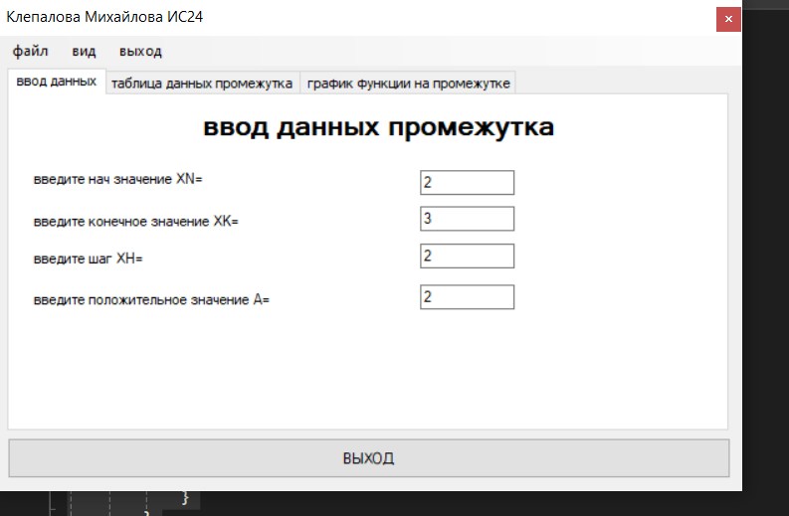
Рис5.Рабочая форма
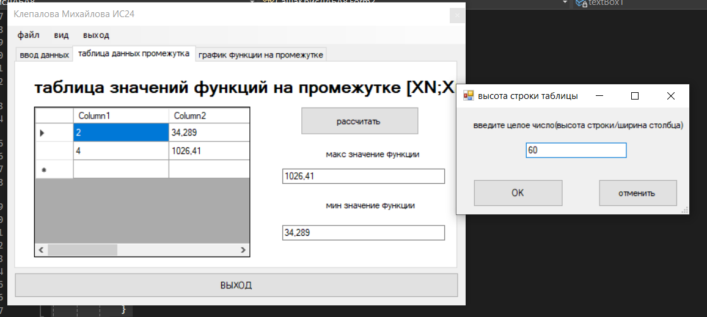
Рис6.Рабочая форма
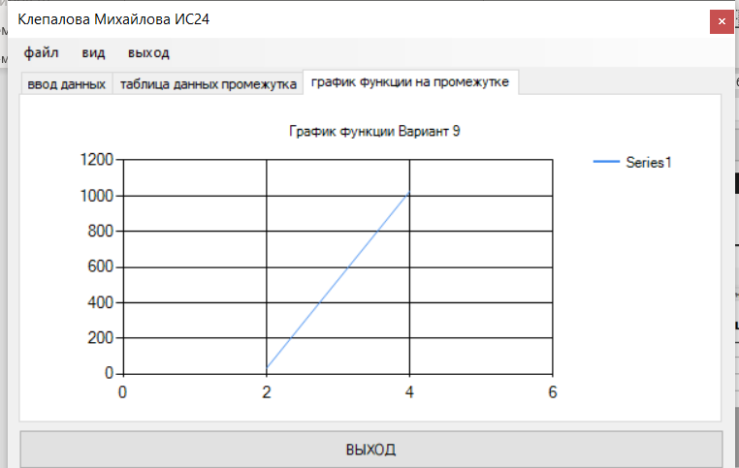
Рис7.Рабочая форма

